
©2006 www.firstschoolyears.com
©2006 www.firstschoolyears.com
©2006 www.firstschoolyears.com
©2006 www.firstschoolyears.com
©2006 www.firstschoolyears.com
©2006 www.firstschoolyears.com
©2006 www.firstschoolyears.com
©2006 www.firstschoolyears.com
Time Cards
Time Cards

Time Cards

Time Cards

Time Cards

Time Cards

Time Cards

Time Cards

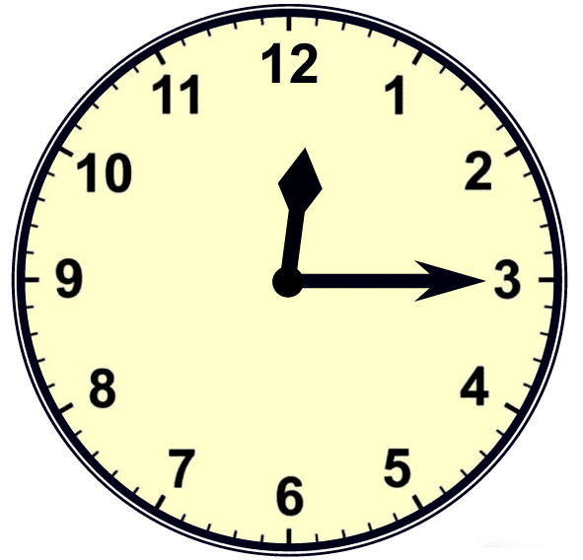
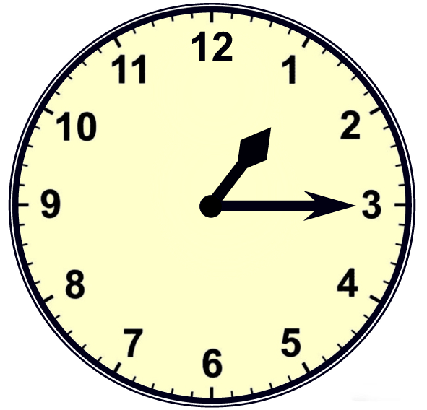
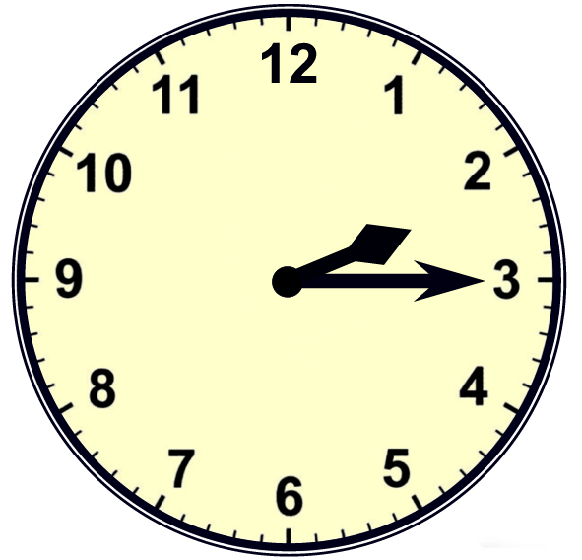
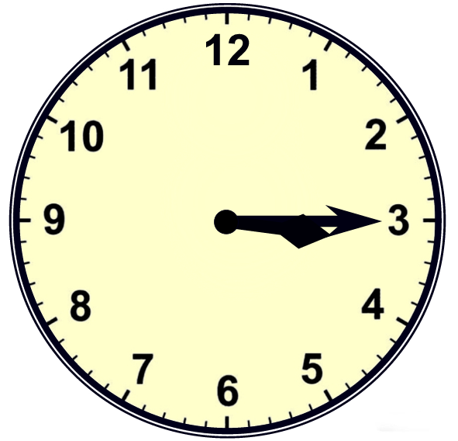
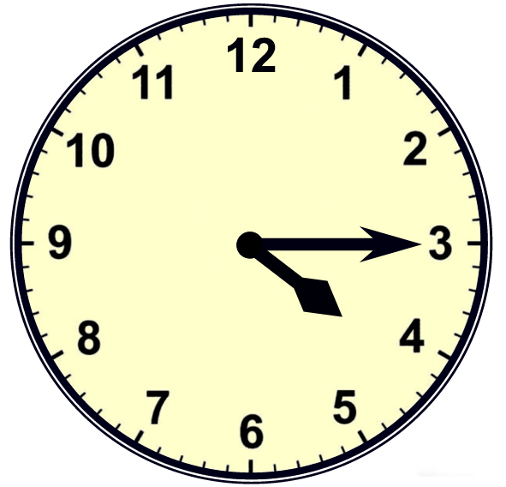
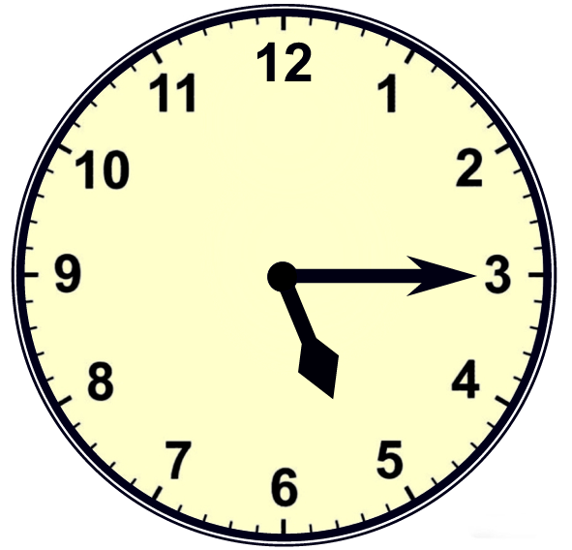
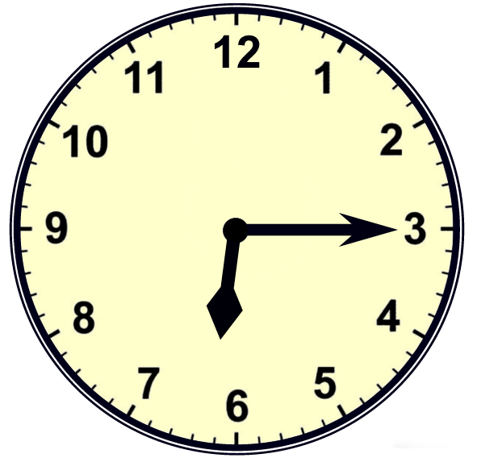
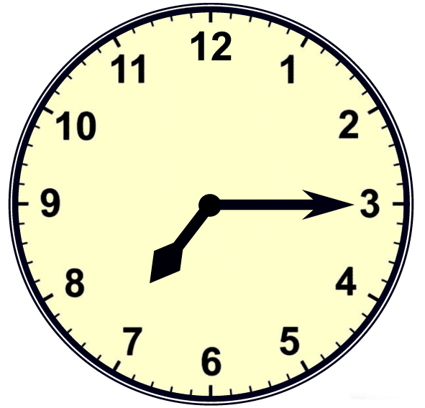
©2006 www.firstschoolyears.com
©2006 www.firstschoolyears.com
©2006 www.firstschoolyears.com
©2006 www.firstschoolyears.com
©2006 www.firstschoolyears.com
©2006 www.firstschoolyears.com
©2006 www.firstschoolyears.com
©2006 www.firstschoolyears.com
Time Cards

Time Cards

Time Cards

Time Cards

Time Cards

Time Cards

Time Cards

Time Cards

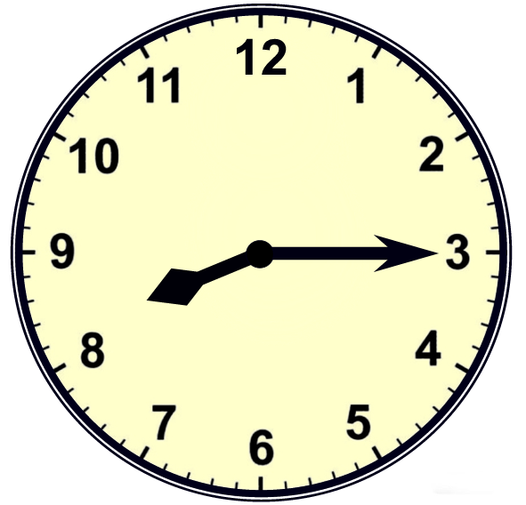
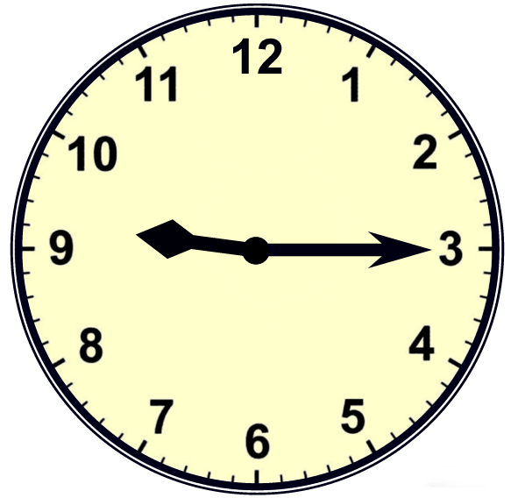
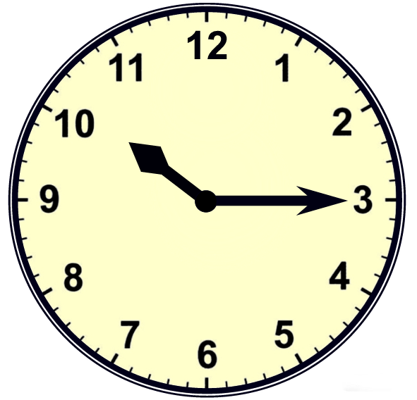
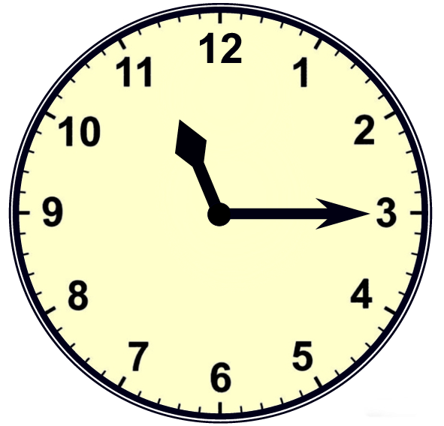




©2006 www.firstschoolyears.com
©2006 www.firstschoolyears.com
©2006 www.firstschoolyears.com
©2006 www.firstschoolyears.com
©2006 www.firstschoolyears.com
©2006 www.firstschoolyears.com
©2006 www.firstschoolyears.com
©2006 www.firstschoolyears.com
Time Cards
Time Cards
Time Cards
Time Cards
Time Cards
Time Cards
Time Cards
Time Cards








©2006 www.firstschoolyears.com
©2006 www.firstschoolyears.com
©2006 www.firstschoolyears.com
©2006 www.firstschoolyears.com
©2006 www.firstschoolyears.com
©2006 www.firstschoolyears.com
©2006 www.firstschoolyears.com
©2006 www.firstschoolyears.com
Time Cards
Time Cards

Time Cards

Time Cards

Time Cards

Time Cards

Time Cards

Time Cards

quarter past 12
quarter past 1
quarter past 2
quarter past 3
quarter past 4
quarter past 5
quarter past 6
quarter past 7
©2006 www.firstschoolyears.com
©2006 www.firstschoolyears.com
©2006 www.firstschoolyears.com
©2006 www.firstschoolyears.com
Time Cards

Time Cards

Time Cards

Time Cards

quarter past 8
quarter past 9
quarter past 10
quarter past 11
©2006 www.firstschoolyears.com
©2006 www.firstschoolyears.com
©2006 www.firstschoolyears.com
©2006 www.firstschoolyears.com
©2006 www.firstschoolyears.com
©2006 www.firstschoolyears.com
©2006 www.firstschoolyears.com
©2006 www.firstschoolyears.com
Time Cards
Time Cards

Time Cards

Time Cards

Time Cards

Time Cards

Time Cards

Time Cards

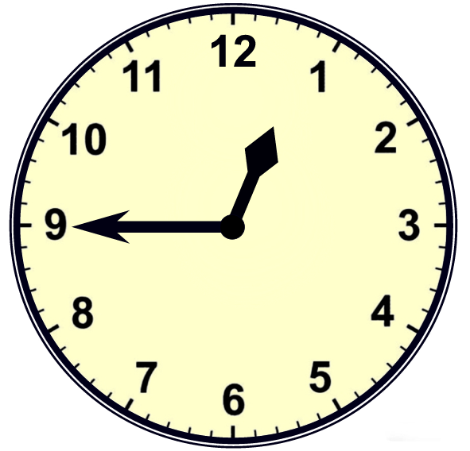
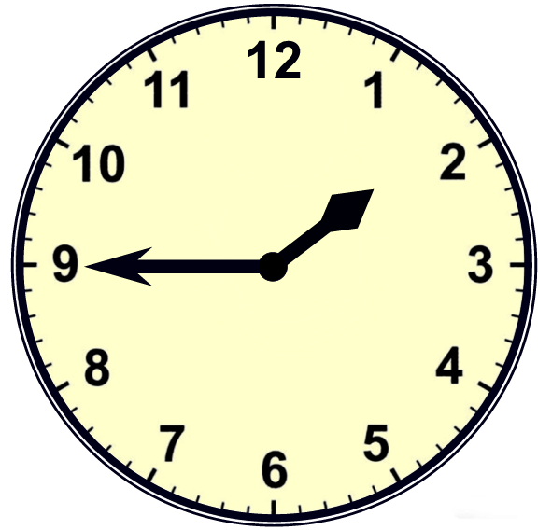
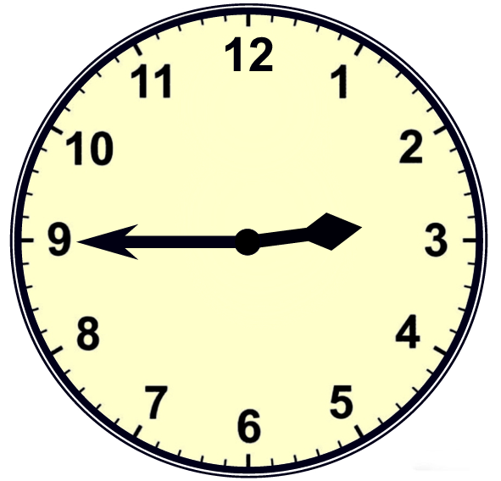
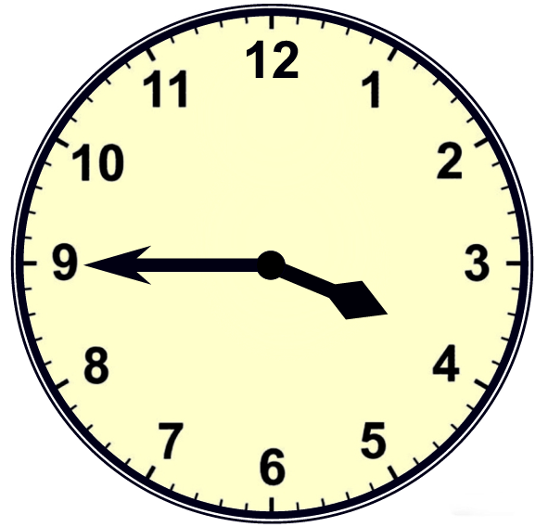
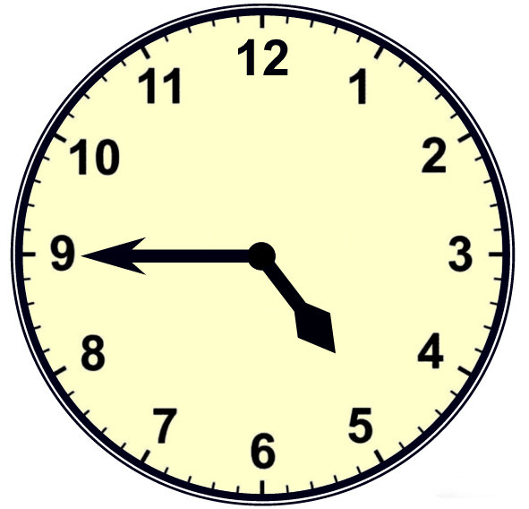
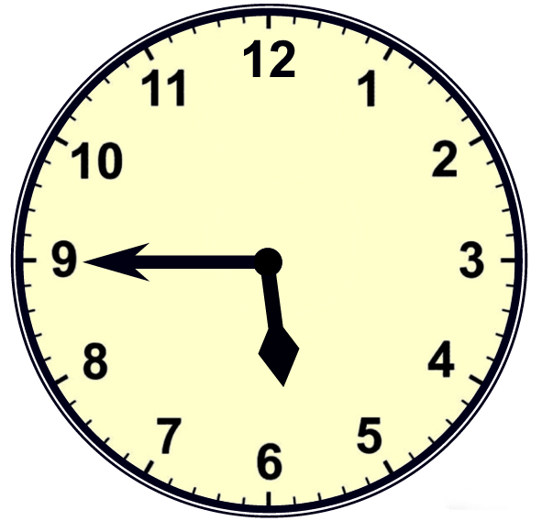
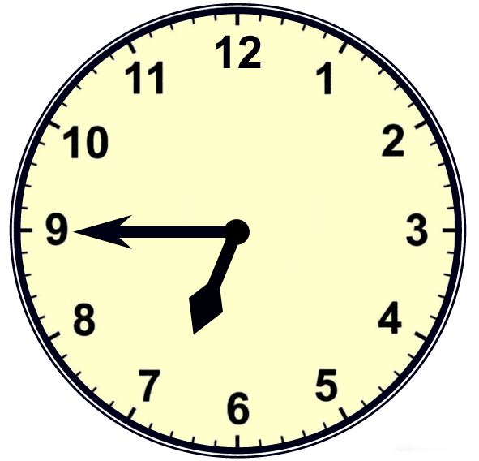
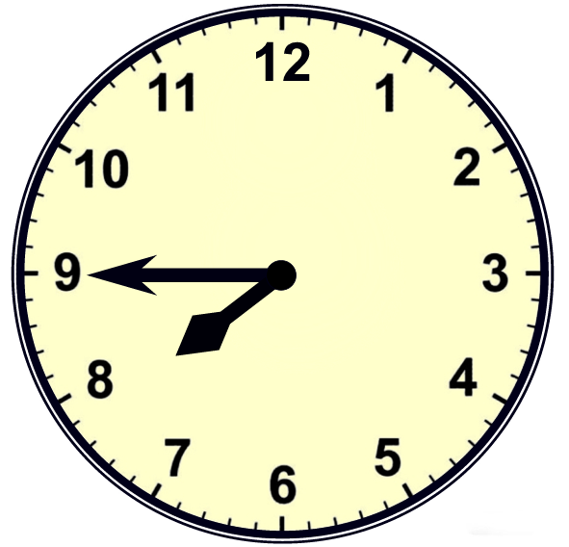
©2006 www.firstschoolyears.com
©2006 www.firstschoolyears.com
©2006 www.firstschoolyears.com
©2006 www.firstschoolyears.com
©2006 www.firstschoolyears.com
©2006 www.firstschoolyears.com
©2006 www.firstschoolyears.com
©2006 www.firstschoolyears.com
Time Cards

Time Cards

Time Cards

Time Cards

Time Cards

Time Cards

Time Cards

Time Cards

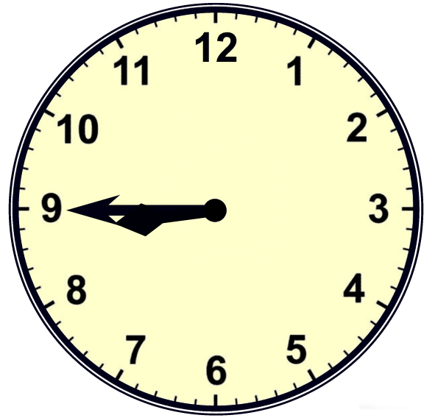
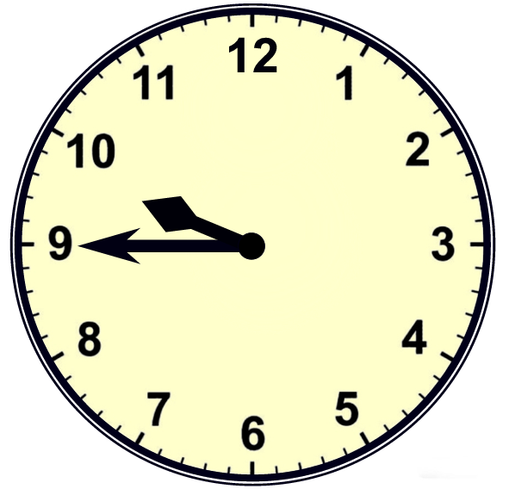
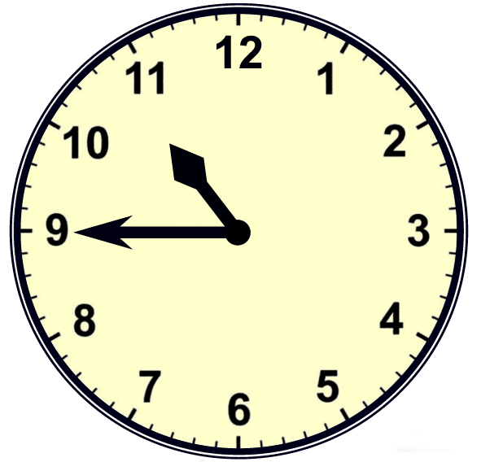
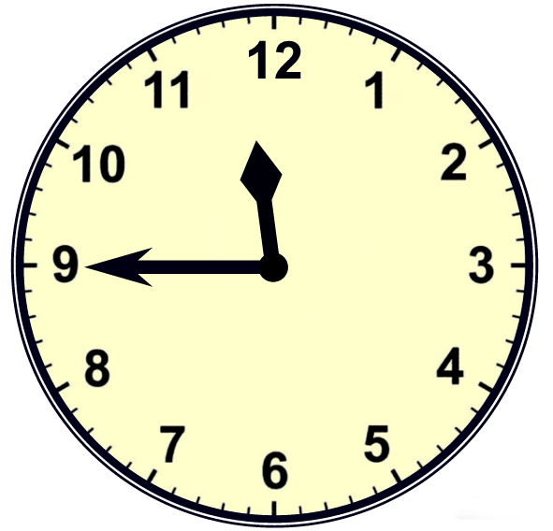




©2006 www.firstschoolyears.com
©2006 www.firstschoolyears.com
©2006 www.firstschoolyears.com
©2006 www.firstschoolyears.com
©2006 www.firstschoolyears.com
©2006 www.firstschoolyears.com
©2006 www.firstschoolyears.com
©2006 www.firstschoolyears.com
Time Cards
Time Cards
Time Cards
Time Cards
Time Cards
Time Cards
Time Cards
Time Cards








©2006 www.firstschoolyears.com
©2006 www.firstschoolyears.com
©2006 www.firstschoolyears.com
©2006 www.firstschoolyears.com
©2006 www.firstschoolyears.com
©2006 www.firstschoolyears.com
©2006 www.firstschoolyears.com
©2006 www.firstschoolyears.com
Time Cards
Time Cards

Time Cards

Time Cards

Time Cards

Time Cards

Time Cards

Time Cards

quarter to 1
quarter to 2
quarter to 3
quarter to 4
quarter to 5
quarter to 6
quarter to 7
quarter to 8
©2006 www.firstschoolyears.com
©2006 www.firstschoolyears.com
©2006 www.firstschoolyears.com
©2006 www.firstschoolyears.com
Time Cards

Time Cards

Time Cards

Time Cards

quarter to 9
quarter to 10
quarter to 11
quarter to 12

